TASK # 01
Lab Task
A digital learning platform is developing a C++ program to manage different types of learning content available for students. The platform provides three types of content: Video lessons, Audio lectures, and Text tutorials. All content types share some common information such as contentID and title. To represent this, the developers create a base class Content that stores these attributes and includes a virtual function displayContent() which shows how the content is delivered to the student. Three derived classes VideoLesson, AudioLecture, and TextTutorial inherit from the Content class. The VideoLesson class adds videoLength (in minutes), the AudioLecture class adds audioLength (in minutes), and the TextTutorial class adds numberOfPages. Each derived class overrides the displayContent() function to display information specific to that type of content. In the main function, create objects of all three derived classes and store their addresses in an array of base class pointers. Use a loop to call the displayContent() function for each object through the base class pointer so that the correct function is executed at runtime. Implement the program in C++ using runtime polymorphism and inheritance.
TASK # 02
A logistics company wants to develop a C++ program to manage different types of delivery services and calculate their shipping costs automatically. Every shipment handled by the company has some common information including shipmentID and weight (in kilograms). To represent this common structure, the developers design a base class named Shipment that stores these attributes and declares a virtual function calculateCost() which will be used to compute the delivery cost.
The company offers three types of delivery services that behave differently:
∙ StandardDelivery – used for normal deliveries within the city. The shipping cost is calculated using the formula:
cost = weight × 5.
∙ ExpressDelivery – used for urgent deliveries. In addition to the weight cost, a fixed priority charge is applied. The cost formula is:
cost = (weight × 8) + 50.
∙ InternationalDelivery – used for shipments sent to other countries. These shipments include customs and long-distance charges. The cost formula is:
cost = (weight × 12) + 100.
The classes StandardDelivery, ExpressDelivery, and InternationalDelivery must inherit from the Shipment class and override the virtual function calculateCost() to implement their respective cost formulas.
In the main function, create objects of all three delivery types and store their addresses in an array of base class pointers of type Shipment. Use a loop to call the calculateCost() function through the base class pointer for each object and display the shipmentID along with the calculated delivery cost.
Design the program in C++ using inheritance, virtual functions, and runtime polymorphism so that the correct cost calculation function is executed depending on the type of shipment.
TASK # 03
Smart Home System
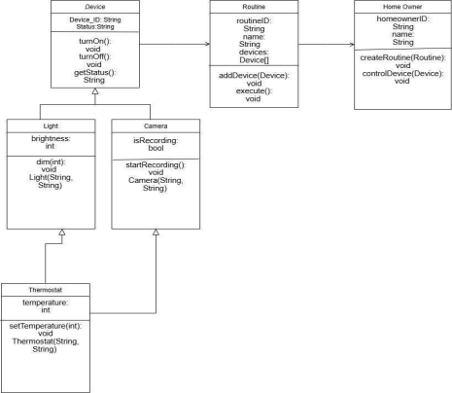
Imagine a futuristic smart home where various devices are interconnected and controlled through a central system. The system manages lighting, security, and climate control. The homeowner can control these devices remotely via a mobile app or through voice commands. The system also learns the homeowner's preferences over time and automates tasks accordingly.
System Overview
The system consists of multiple smart devices, including lights, cameras, and thermostats. Each device has a unique identifier and a status indicating whether it is turned on or off. The system also allows homeowners to create custom routines that automate multiple devices simultaneously
Class Descriptions
Device
Represents a general smart home device.
∙ Attributes:
o deviceID (String) – Unique identifier for the device
o status (String) – Indicates whether the device is ON or OFF
∙ Methods:
o turnOn(): Turns the device ON
o turnOff(): Turns the device OFF
o getStatus(): Returns the current status of the device
Light
A smart light that can be turned on, off, or dimmed.
∙ Attributes:
o brightness (int) – Represents the brightness level of the light
∙ Methods:
o dim(int level): Adjusts the brightness of the light
Camera
A security camera that can record.
∙ Attributes:
o isRecording (boolean) – Indicates if the camera is currently recording ∙ Methods:
o startRecording(): Starts recording
Thermostat
A temperature-controlling device.
∙ Attributes:
o temperature (int) – Represents the current temperature setting
∙ Methods:
o setTemperature(int temp): Sets the temperature
Routine
Represents a smart home automation routine that controls multiple devices together.
∙ Attributes:
o routineID (String) – Unique identifier for the routine
o name (String) – Name of the routine
o devices (List of Devices) – A list of devices included in the routine ∙ Methods:
o addDevice(Device device): Adds a single device to the routine o addDevice(Device[] devices): Adds multiple devices to the routine o execute(): Activates all devices in the routine
Homeowner
Represents the homeowner who controls the smart home system.
∙ Attributes:
o homeownerID (String) – Unique identifier for the homeowner o name (String) – Name of the homeowner
∙ Methods:
o createRoutine(Routine routine): Creates a new routine
o controlDevice(Device device): Controls a single device
Sample Input:
Create Light: ID = L1, Status = OFF, Brightness = 80
Create Camera: ID = C1, Status = OFF, Recording = false
Create Thermostat: ID = T1, Status = OFF, Temperature = 24
Turn on Light L1
Dim Light L1 to 50%
Start recording on Camera C1
Set temperature of Thermostat T1 to 22°C
Create Routine "Morning Mode"
Add Light L1, Camera C1, Thermostat T1 to Routine "Morning Mode" Execute Routine "Morning Mode"
Sample Output:
Light L1 turned ON
Light L1 brightness set to 50% Camera C1 started recording Thermostat T1 temperature set to 22°C Routine "Morning Mode" executed: Light L1 turned ON
Camera C1 started recording Thermostat T1 temperature set to 22°C

